Linux Desktop email client configuration

These guides use Ubuntu as an example but will also work with other Linux distributions with minor adjustments. If the correct configuration is supplied, you don’t need anything from the service desk to activate or use O365 email accounts on a Linux desktop.
We suggest using apt and not flatpack or snap on Ubuntu for installation.

Evolution
To use evolution, you must install the “evolution-ews” package.
Start the add account process: Edit menu >> Accounts

Add >> Mail Account
Identity
- Enter Name
- Email address: eg: j.smith@unsw.edu.au
- Untick Look up mail server...
- Receiving Email
  - Server Type: Exchange Web Services
  - Username: eg. z1234567@ad.unsw.edu.au
  - Host URL: https://outlook.office365.com/EWS/Exchange.asmx
  - OAB URL: https://outlook.office365.com/OAB/cd82899d-918f-4d3d-85ac-7aae65ddec7b/oab.xml
  - Authentication: OAuth2 (Office365)
  - Application ID: d3590ed6-52b3-4102-aeff-aad2292ab01c
  - Endpoint host: login.microsoftonline.com
  - Redirect URI: urn:ietf:wg:oauth:2.0:oob
  - Click Fetch URL → z1234567@ad.unsw.edu.au → ...
- Click Next

- Receiving Options
  - Check for new messages every: 5 mins
  - Click Next, and Next again

The Identity section of Evolution:
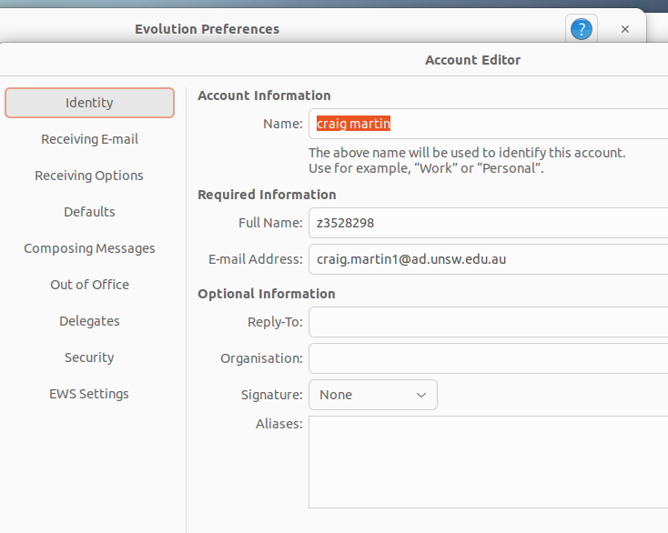
The Receiving E-Mail section of Evolution:
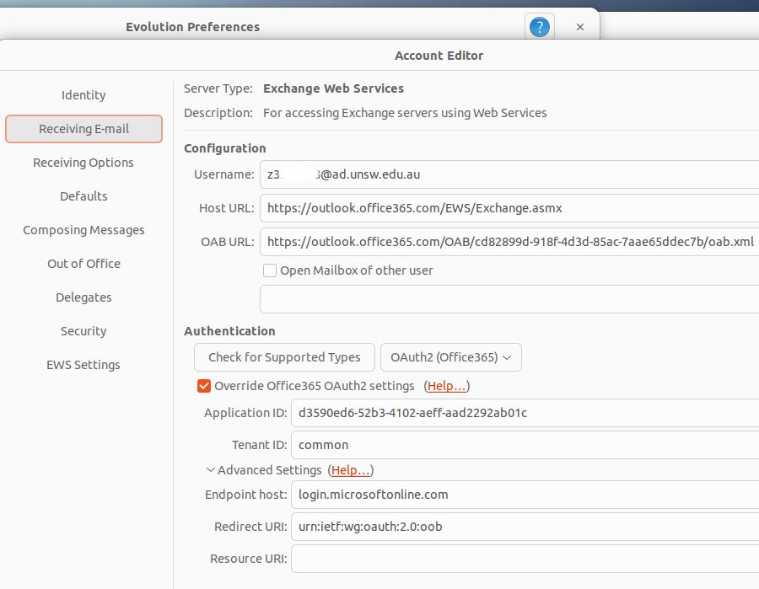

Thunderbird

Account Settings → Account Actions → Add Mail Account
Email Address: your-email@unsw.edu.au
- Password: enter your zID password
- Click: Configure Manually

Incoming Server

- Protocol: IMAP
- Hostname: outlook.office365.com
- Port: 993
- Connection security: SSL/TLS (or Autodetect)
- Authentication method: OAuth2
- Username: zid@ad.unsw.edu.au

Outgoing Server

- Hostname: smtp.office365.com
- Connection security: STARTTLS (or Autodetect)
- Port: 587
- Authentication method: OAuth2 (or Autodetect)
(If OAuth2 isn't visible, set Connection security to STARTTLS, close the window or skip for now, then come back and try editing this again)
- Username: zid@ad.unsw.edu.au
- When finished click: Advanced config

